Request for Proposals
23-100
Program Administration and Investment Management Services for the New York State Secure Choice Savings Program

Exhibits

Table of Contents

EXHIBIT A
NYS General Business Law Article 43 3
EXHIBIT B
Draft Investment Policy Statement 14
EXHIBIT C
New York State Office of the State Comptroller Substitute Form W-9 21
EXHIBIT D
Minority and Women-Owned Business Enterprises – Equal Employment Opportunity Policy Statement 23
EXHIBIT E
Contractor Sales Tax Certification Forms 25
EXHIBIT F
Workforce Utilization Report 31

EXHIBIT A

NYS General Business Law Article 43
New York State Secure Choice Savings Program
General Business
ARTICLE 43
NEW YORK STATE SECURE CHOICE SAVINGS PROGRAM

Section

1300. Definitions.

1301. Program established.
1302. Composition of the board.
1303. Fiduciary duty.
1304. Duties of the board.
1305. Risk management.
1306. Financial organizations.

1307. Investment options.

1308. Benefits.

1309. Employer and employee informational materials and disclosure forms.
1310. Program implementation and enrollment.
1311. Payments.

1312. Duty and liability of the state.

1313. Duty and liability of participating employers.
1314. Audit and reports.
1315. Delayed implementation.

1316. Regulations.

General Business

§ 1300. Definitions. All terms shall have the same meaning as when used in a comparable context in the Internal Revenue Code. As used in this article, the following terms shall have the following meanings:
- "Board" shall mean the New York secure choice savings program board established under this article.
- "Superintendent" shall mean the superintendent of the department of financial services.
2-a. "Commissioner" shall mean the commissioner of taxation and finance.
2-b. "Comptroller" shall mean the comptroller of the state.
- "Employee" shall mean any individual who is eighteen years of age or older, who is employed by an employer, and who earned wages working for an employer in New York state during a calendar year.
- "Employer" shall mean a person or entity engaged in a business, industry, profession, trade, or other enterprise in New York state, whether for profit or not for profit, that (i) has at all times during the previous calendar year employed at least ten employees in the state, (ii) has been in business at least two years, and (iii) has not offered a qualified retirement plan, including, but not limited to, a plan qualified under sections 401(a), 401(k), 403(a), 403(b), 408(k), 408(p) or 457(b) of the Internal Revenue Code of 1986 in the preceding two years.
- "Enrollee" shall mean any employee who is enrolled in the program.
- "Internal Revenue Code" shall mean the Internal Revenue Code of 1986, or any successor law, in effect for the calendar year.
- "IRA" shall mean a Roth IRA (individual retirement account).
- "Participating employer" shall mean an employer that facilitates access to the program's payroll deduction IRA as provided for by this article for its employees who are enrollees in the program.
- "Payroll deduction IRA" shall mean an arrangement by which a participating employer facilitates access for enrollees to remit payroll deduction contributions to the program.
- "Program" shall mean the New York state secure choice savings program.
- "Wages" means any compensation within the meaning of section 219(f)(1) of the Internal Revenue Code that is received by an enrollee from a participating employer during the calendar year.

§ 1301. Program established. There is hereby established a retirement savings program in the form of an automatic enrollment payroll deduction IRA, known as the New York state secure choice savings program. The general administration and responsibility for the proper operation of the program shall be administered by the board for the purpose of promoting greater retirement savings for private-sector employees in a convenient, low-cost, and portable manner. The board may delegate such authority and responsibility for the development and implementation of the program to the department of taxation and finance as the board deems proper.

§ 1302. Composition of the board. There is hereby created the New York state secure choice savings program board.
- The board shall consist of the following seven members:
- the commissioner, or his or her designee, who shall serve as chair;
- the state comptroller, or his or her designee;
- the superintendent, or his or her designee;
- two public representatives with expertise in retirement savings plan administration or investment, or both, one of whom shall be appointed by the speaker of the assembly and one of whom shall be appointed by the temporary president of the senate;
- a representative of participating employers, appointed by the governor; and
- a representative of enrollees, appointed by the governor.
- Members of the board shall serve without compensation but may be reimbursed for necessary travel expenses incurred in connection with their board duties from funds appropriated for the purpose.
- The initial appointments shall be as follows: the public representatives for four years; the representative of participating employers for three years; and the representative of enrollees for three years. Thereafter, all the governor's appointees shall be for terms of four years.
- A vacancy in the term of an appointed board member shall be filled for the balance of the unexpired term in the same manner as the original appointment.

§ 1303. Fiduciary duty. The board, the individual members of the board, the trustees, any other agents appointed or engaged by the board, and all persons serving as program staff shall discharge their duties with respect to the program solely in the interest of the program's enrollees and beneficiaries as follows:
- for the exclusive purposes of providing benefits to enrollees and beneficiaries and defraying reasonable expenses of administering the program;
- by investing with the care, skill, prudence, and diligence under the prevailing circumstances that a prudent person acting in a like capacity and familiar with those matters would use in the conduct of an enterprise of a like character and with like aims; and
- by using any contributions paid by employees and employers remitting employees' own contributions into the fund exclusively for the purpose of paying benefits to the enrollees of the program, for the cost of administration of the program, and for investments made for the benefit of the program.

§ 1304. Duties of the board. In addition to the other duties and responsibilities stated in this article, the board shall, itself or through the use of appropriate financial organizations as managers:
- Cause the program to be designed, established and operated in a manner that:
- accords with best practices for retirement savings vehicles;
- maximizes participation, savings, and sound investment practices including considering the use of automatic enrollment as allowed under federal law;
- maximizes simplicity, including ease of administration for participating employers and enrollees;
- provides an efficient product to enrollees by pooling investment funds;
- ensures the portability of benefits; and
- provides for the deaccumulation of enrollee assets in a manner that provides a financial benefit in retirement.
- Explore and establish or authorize investment options, subject to this article, that offer enrollees returns on contributions and the conversion of individual retirement savings account balances to secure retirement income without incurring debt or liabilities to the state.
- Establish or authorize the process by which interest, investment earnings, and investment losses are allocated to individual program accounts on a pro rata basis and are computed at the interest rate on the balance of an individual's account.
- Make and enter into contracts necessary for the administration of the program and fund, including, but not limited to, retaining and contracting with investment managers, financial organizations, other financial and service providers, consultants, actuaries, counsel, auditors, third-party administrators, and other professionals as necessary.
- Conduct a periodic review of the performance of any financial organizations, including, but not limited to, a review of returns, fees, and customer service. A copy of reviews shall be posted to the program's Internet website.
- Cause moneys in the program to be held and invested as pooled investments or otherwise, with a view to achieving cost savings through efficiencies and economies of scale.
- Evaluate and establish or authorize the process for:
- an enrollee to contribute a portion of his or her wages to the program via payroll deduction; and
- the enrollment of participating employers in the program.
- The board may contract with financial organizations and third-party administrators with the capability to receive and process employee information and contributions for payroll deduction IRA or similar arrangements.
- Evaluate and establish or authorize the process for enrollment including the process by which an employee may opt not to participate in the program, select a contribution level, select an investment option, and terminate participation in the program.
- Evaluate, or cause to be evaluated, the need for, and procure as needed, insurance against any and all loss in connection with the property, assets, or activities of the program, and indemnify as needed each member of the board from personal loss or liability resulting from a member's action or inaction as a member of the board.
- Make provisions for the payment of administrative costs and expenses for the creation, management, and operation of the program. Subject to appropriation, the state may pay administrative costs associated with the creation and management of the program until sufficient assets are available in the program for that purpose. Thereafter, all administrative costs of the program, including repayment of any start- up funds provided by the state, shall be paid only out of moneys on deposit therein. However, private funds or federal funding received in order to implement the program until it is self-sustaining shall not be repaid unless those funds were offered contingent upon the promise of such repayment. The board shall keep its annual administrative expenses as low as possible.
- Allocate administrative fees to individual retirement accounts in the program on a pro rata basis.
- Set or authorize minimum and maximum contribution levels in accordance with limits established for IRAs by the Internal Revenue Code.
- Facilitate education and outreach to employers and employees.
- Facilitate compliance by the program with all applicable requirements for the program under the Internal Revenue Code, including tax qualification requirements or any other applicable legal, financial reporting and accounting requirements.
- Carry out the duties and obligations of the program in an effective, efficient, and low-cost manner.
- Exercise any and all other powers reasonably necessary for the effectuation of the purposes, objectives, and provisions of this article.
- Determine or authorize withdrawal provisions, such as economic hardships, portability and leakage.
- Determine employee rights and enforcement of penalties.
- Delegate such authority and responsibility for the development and implementation of the program to the department of taxation and finance as the board deems proper.

§ 1305. Risk management. The board shall annually prepare, or cause to be prepared, and adopt a written statement of investment policy that includes a risk management and oversight program. This investment policy shall prohibit the board and the program from borrowing for investment purposes. The risk management and oversight program shall be designed to ensure that an effective risk management system is in place to monitor the risk levels of the program, to ensure that the risks taken are prudent and properly managed, to provide an integrated process for overall risk management, and to assess investment returns as well as risk to determine if the risks taken are adequately compensated compared to applicable performance benchmarks and standards. The board shall consider the statement of investment policy and any changes in the investment policy at a public hearing.

§ 1306. Financial organizations. 1. The board shall engage, after an open bid process, a financial organization or organizations to invest assets of the program. In selecting the financial organization or organizations, the board shall take into consideration and give weight to the financial organization's fees and charges in order to reduce the program's administrative expenses.
- The financial organizations shall comply with applicable federal and state laws, rules, and regulations, as well as rules, policies, and guidelines promulgated by the board with respect to the program, including, but not limited to, the investment policy.
- The financial organization or organizations shall provide such reports as the board deems necessary for the board to oversee each financial organization's performance and the performance of the program.

§ 1307. Investment options. 1. The board shall establish or authorize a default investment option for enrollees who fail to elect an investment option. In making such determination, the board shall consider the cost, risk profile, benefit level and ease of enrollment. The board may change the default option if the board determines that such change is in the best interests of the enrollees.
- The board may establish or authorize any additional investment options that the board deems appropriate including but not limited to:
- a conservative principal protection fund;
- a growth fund;
- a secure return fund whose primary objective is the preservation of the safety of principal and the provision of a stable and low-risk rate of return; if the board elects to establish a secure return fund, the board may procure any insurance, annuity, or other product to insure the value of enrollees' accounts and guarantee a rate of return; the cost of such funding mechanism shall be paid out of the fund; under no circumstances shall the board, program, fund, the state, or any participating employer assume any liability for investment or actuarial risk; the board shall determine whether to establish or authorize such investment options based upon an analysis of their cost, risk profile, benefit level, feasibility, and ease of implementation;
- an annuity fund;
- a growth and income fund; or
- a life cycle fund with a target date based upon factors determined by the board.

§ 1308. Benefits. Interest, investment earnings, and investment losses shall be allocated to individual program accounts as authorized by the board pursuant to this article. An individual's retirement savings benefit under the program shall be an amount equal to the balance in the individual's program account on the date the retirement savings benefit becomes payable. The state shall have no liability for the payment of any benefit to any enrollee in the program.

§ 1309. Employer and employee informational materials and disclosure forms. 1. Prior to the opening of the program for enrollment, the board shall design and disseminate, or cause to be designed and disseminated, to all employers employer informational materials and employee informational materials, which shall include background information on the program, and necessary disclosures as required by law for employees.
- The employee informational materials shall be made available in English, Spanish, Haitian Creole, Chinese, Korean, Russian, Arabic, and any other language the board deems necessary.
- The employee informational materials shall include a disclosure form. The disclosure form shall explain, but not be limited to, all of the following:
- the benefits and risks associated with making contributions to the program;
- the process for making contributions to the program;
- how to opt out of the program;
- the process by which an employee can participate in the program with a level of employee contributions other than three percent;
- that they are not required to participate or contribute more than three percent;
- the process for withdrawal of retirement savings;
- the process for selecting beneficiaries of their retirement savings;
- how to obtain additional information about the program;
- that employees seeking financial advice should contact financial advisors, that participating employers are not in a position to provide financial advice, and that participating employers are not liable for decisions employees make pursuant to this article;
- information on how to access any available financial literacy programs;
- that the program fund is not guaranteed by the state; and
- that they can opt out after they have been enrolled.
- The employee informational materials shall also include a form for an employee to note his or her decision to opt out of participation in the program or elect to participate with a level of employee contributions other than three percent.
- Participating employers shall supply the employee informational materials to existing employees at least one month prior to the participating employers' facilitation of access to the program. Participating employers shall supply the employee informational materials to new employees at the time of hiring and new employees may opt out of participation in the program.

§ 1310. Program implementation and enrollment. Except as otherwise provided in this article, the program shall be implemented, and enrollment of employees shall begin no later than December thirty-first, two thousand twenty-one. The provisions of this section shall be in force after the board opens the program for enrollment.
- (a) Each participating employer shall have a payroll deposit retirement savings arrangement to allow each employee to participate in the program at most nine months after the board opens the program for enrollment.
(b) Participating employers shall automatically enroll in the program each of their employees who has not opted out of participation in the program using the form described in this article and shall provide payroll deduction retirement savings arrangements for such employees and deposit, on behalf of such employees, these funds into the program.
- Enrollees shall have the ability to select a contribution level into the program. This level may be expressed as a percentage of wages or as a dollar amount up to the deductible amount for the enrollee's taxable year under section 219(b)(1)(A) of the Internal Revenue Code. Enrollees may change their contribution level at any time, subject to rules promulgated by the board. If an enrollee fails to select a contribution level using the form described in this article, then he or she shall contribute three percent of his or her wages to the program, provided that such contributions shall not cause the enrollee's total contributions to IRAs for the year to exceed the deductible amount for the enrollee's taxable year under section 219(b)(1)(A) of the Internal Revenue Code. The deduction of contributions from an employee's wages shall not begin until the thirtieth day after such employee has been enrolled in the program.
- Enrollees may select an investment option offered under the program. Enrollees may change their investment option at any time, subject to rules promulgated by the board. In the event that an enrollee fails to select an investment option, that enrollee shall be placed in the investment option selected or authorized by the board as the default under this article.
- Following initial implementation of the program pursuant to this section, at least once every year, the program shall designate an open enrollment period during which employees who previously opted out of the program may enroll in the program.
- An employee who opts out of the program and who subsequently wants to participate may only enroll during the program's designated open enrollment period or if permitted by the program at an earlier time.
- Employers shall retain the option at all times to set up any type of employer- sponsored retirement plan.
- An enrollee may terminate his or her enrollment in the program at any time in a manner prescribed by the board.
- (a) The board shall establish or authorize a website regarding the secure choice savings program.
(b) The board shall establish and maintain or authorize the establishment and maintenance of a secure website wherein enrollees may log in and acquire information regarding contributions and investment income allocated to, withdrawals from, and balances in their program accounts for the reporting period. Such website must also include information for the enrollees regarding other options available to the employee and how they can transfer their accounts to other programs should they wish to do so. Such website may include any other information regarding the program as the board may determine.
- A person or entity engaged in a business, industry, profession, trade, or other enterprise in New York state, whether for profit or not for profit, that offers a qualified retirement plan, including, but not limited to, a plan qualified under sections 401(a), 401(k), 403(a), 403(b), 408(k), 408(p) or 457(b) of the Internal Revenue Code of 1986 shall not terminate such plan for the purposes of participating in the program.

§ 1311. Payments. Employee contributions deducted by the participating employer through payroll deduction shall be remitted by the participating employer to the program using one or more payroll deduction IRAs established or authorized by the board under this article, either:
- on or before the last day of the month following the month in which the compensation otherwise would have been payable to the employee in cash; or
- before such later deadline prescribed by the board for making such payments, but not later than the due date for the deposit of tax required to be deducted and withheld relating to collection of income tax at source on wages or for the deposit of tax required to be paid under the unemployment insurance system for the payroll period to which such payments relate.

§ 1312. Duty and liability of the state. 1. The state shall have no duty or liability to any party for the payment of any retirement savings benefits accrued by any enrollee under the program. Any financial liability for the payment of retirement savings benefits in excess of funds available under the program shall be borne solely by the entities with whom the board contracts to provide insurance to protect the value of the program.
2. No state board, commission, or agency, or any officer, employee, or member thereof is liable for any loss or deficiency resulting from particular investments selected under this article, except for any liability that arises out of a breach of fiduciary duty.

§ 1313. Duty and liability of participating employers. 1. Participating employers shall not have any liability for an employee's decision regarding whether to participate in, or opt out of, the program or for the investment decisions of the board or of any enrollee.
2. A participating employer is not establishing or maintaining the program's payroll deduction IRA. A participating employer shall not be a fiduciary, or considered to be a fiduciary, over the program. A participating employer shall not bear responsibility for the administration, investment, or investment performance of the program. A participating employer shall not be liable with regard to investment returns, program design, and benefits paid to program participants.

§ 1314. Audit and reports. 1. The board shall annually submit:
- an audited financial report, prepared in accordance with generally accepted accounting principles, on the operations of the program during each calendar year by July first of the following year to the governor, the commissioner, the speaker of the assembly, the temporary president of the senate, the chair of the assembly ways and means committee, the chair of the senate finance committee, the chair of the assembly labor committee, the chair of the senate labor committee; and
- a report prepared or authorized by the board, which shall include, but is not limited to, a summary of the benefits provided by the program, including the number of enrollees in the program, the percentage and amounts of investment options and rates of return, and such other information that is relevant to make a full, fair, and effective disclosure of the operations of the program. The annual report shall be made by an independent certified public accountant and shall include, but is not limited to, direct and indirect costs attributable to the use of outside consultants, independent contractors, and any other persons who are not state employees for the administration of the program.
2. In addition to any other statements or reports required by law, the board shall provide or cause to be provided periodic reports at least annually to enrollees, reporting contributions and investment income allocated to, withdrawals from, and balances in their program accounts for the reporting period. Such reports may include any other information regarding the program as the board may determine.

§ 1315. Delayed implementation. The board may delay the implementation of the program an additional twelve months beyond the date established in section thirteen hundred ten of this article if the board determines that further delay is necessary to address legal, financial or other programmatic concerns impacting the viability of the program. The board shall provide reasonable notice of such delay to the governor, the commissioner, the speaker of the assembly, the temporary president of the senate, the chair of the assembly ways and means committee, the chair of the senate finance committee, the chair of the assembly labor committee, and the chair of the senate labor committee.

§ 1316. Regulations. The commissioner may issue such rules and regulations as he or she deems necessary to implement the terms of this article.

EXHIBIT B

Draft Investment Policy Statement
INTRODUCTION
DRAFT
This Investment Policy Statement (“IPS”) is designed to provide a framework within which to manage and monitor the investments of the New York State Secure Choice Savings Program (the “Program”).

Statement of Intent

This IPS has been adopted by the Program in order to:

- Define and assign the responsibilities of all involved parties.
- Establish objectives and criteria for the Program’s investment lineup and risk management.
- Establish a basis for evaluating the Program’s investment options.
- Provide flexibility for the amendment of the policy to accommodate for evolving best practices, regulatory requirements, and market conditions.

In accordance with. General Business Law (“GBL”) Article 43 §§ 1300-1316, the New York Secure Choice Savings Program Board (the “Board”) and the New York State Department of Taxation and Finance (the “Department”), acting at the direction of, and as staff to, the Board, will discharge its duties with respect to the Program solely in the interest of the enrollees and beneficiaries of the Program (“Participants”) and for the exclusive purposes of providing benefits to the Participants and defraying reasonable expenses of administering the Program. It is the intent of the Board that it, and any other appointed fiduciary on behalf of the Program, shall perform its duties with the care, skill, prudence, and diligence under the prevailing circumstances that a prudent person acting in like capacity and familiar with such matters would use in the conduct of an enterprise of a like character and with like aims.

The Program was created to provide private-sector employees a convenient, low-cost and portable investment program to promote greater retirement savings. While the Board administers the Program and oversees the investment options to be offered, all individual investment decisions under the Program are at the sole discretion of Participants on whose behalf the Program holds assets. Per GBL Art. 43, § 1305, the Board and the Program are prohibited from borrowing for investment purposes.

This IPS will be reviewed at least annually and amended by the Board as needed.

DELINEATION OF RESPONSIBILITIES

Responsibilities of the Board and the Department

The Board itself or by delegation to the Department have the following responsibilities:
- Establish this IPS, monitor implementation thereof, and review annually.
- Select the investment design features of the Program in accordance with GBL Art. 43, §§ 1304 and 1307, including establishing the number and types of investment options available to Participants, as well as determining the default investment option for Participants.
- Use available information and resources, including advice from the Investment Consultant to select, monitor and evaluate the Program’s investment options in accordance with guidelines and benchmarks established within this IPS.
- Periodically review Program costs which are charged to Program assets and/or paid by Participants, including but not limited to investment option expense ratios, and Program Administration fees.
- Provide, in conjunction with the Program Administrator, general investment information to Participants regarding the procedures for making investment choices under the Program and general investment information regarding each of the investment options offered under the Program.

DELEGATION TO SERVICE PROVIDERS

The Board is authorized to delegate any of its duties or responsibilities, subject to the supervision of the Department, acting at the direction of, and as staff to, the Board, and to retain service providers (e.g., advisors, actuaries, lawyers and other experts) to advise the Board with respect to the discharge of its duties and responsibilities, with the express condition that the Board shall remain responsible for monitoring the appropriateness of any such delegation and, to the extent that the party to whom the Board has delegated authority does not assume fiduciary responsibility, retain full and exclusive authority over and responsibility for any duties and responsibilities so delegated. Service providers to whom the duties or responsibilities to be delegated may include, but are not limited to:
DRAFT

Investment Consultant

The Program’s external Investment Consultant shall have the following responsibilities:
- Comply with applicable laws, regulations, and rulings.
- Assist the Board in fulfilling its responsibilities in accordance with this IPS.
- Provide advice to the Board and, where appropriate, make recommendations on various investment-related issues with respect to the structure and selection of the Program’s investment options.
- Provide the Board with periodic reporting regarding the Program and monitor the performance and soundness of the Program’s investment option managers.
- Evaluate the Program’s investment options in general with respect to risk and return, fees, and the diversity of the options offered; this includes providing information, analysis and processes regarding the removal, addition, or replacement of investment options.
- Review this IPS on a regular basis and recommend modifications as appropriate.
- Promptly inform the Board regarding significant matters pertaining to the Program’s investment options.

Investment Manager

The Program’s Investment Manager(s) shall have the following responsibilities:
- Comply with applicable laws, regulations, and rulings.
- Provide recommendations on investment options, guidelines, and this IPS.
- Provide accurate and timely Program data and reports to the Board and Investment Consultant, such as:
  - Written review of performance and portfolio structure.
  - Summary of investment decision adjustments with reasoning and forward-looking expectations of those changes, if any.
  - Organizational updates.
  - Informational / Educational pieces on markets, economy and any other factors tied to performance.
- Manage the portion of the Program’s assets under their control in accordance with this IPS and any applicable management agreement or prospectus.
- Promptly inform the Investment Consultant regarding significant matters pertaining to the investment of the Program’s assets, including, but not limited to changes in ownership, organizational structure, investment strategy, portfolio design, or configuration of the investment team.

Program Administrator

- Administer certain Plan functions for Participants, including: processing enrollment, contribution and investment elections; processing withdrawals; maintaining individual accounts; preparing and delivering account statements and summary reports; reporting historical performance; and educating Participants.
DRAFT
- Maintain possession of securities owned by the Participants in an accurate and confidential manner. Provide Participants with electronic access to account information and transactions.
- Prepare and distribute required Participant notices.

INVESTMENT OBJECTIVES

Investment Principles

The Program’s investment principle is to provide Participants with sufficient information to make informed decisions when selecting from a menu of low-cost, simple investment options that satisfy investment objectives and afford Participants the opportunity to save current compensation in a tax-effective manner that meets their individual retirement goals.

In selecting the investment options that are available under the Program and in determining whether to retain those options, the Board believes that the achievement of investment returns should be viewed in a long-term context. The Board recognizes that rates of return are volatile on a year-to-year basis and that investment returns may not progress uniformly over time.

Investment Criteria

Given expectations of investment returns in a long-term context, and GBL Art. 43, § 1307, the investment options provided to Participants should include target date funds and separate target-risk investment options, which could be based upon a single underlying fund. These options should provide Participants with the possibility of low cost, target-risk investments as an alternative to target date funds. Only marketable securities will be used for broad asset classes. These asset allocation strategies should be divided into the following broad asset class categories:

- Cash / Money Market / Short-Term Equivalent funds
- Fixed Income funds
- Real Estate funds
- Domestic Equity funds
- International Equity funds

Participants will determine how their contributions are invested within the investment options offered by the Program; the individual Participant’s investment performance will be dictated by these decisions.

INVESTMENT OPTIONS AND EVALUATION

Investment Options
At the outset, the Program will offer the following options:
- Target Retirement Date Funds
- Growth Fund
- Growth and Income Fund
- Conservative Principal Protection Fund

The Board and the Investment Consultant will review the viability of providing additional investment options and/or underlying investment funds in the future, at the discretion of the Board.
DRAFT
Target Retirement Date Funds
Target retirement date funds are structured to provide Participants with an asset allocation that changes dynamically over time. As the investment horizon shortens and draws nearer to the retirement date, the fund will gradually reweight its asset allocation composition towards a higher focus on income generation and capital preservation. This helps in emphasizing asset growth for younger Participants and advances towards a higher focus on asset maintenance. The target retirement date funds will be diversified across various asset classes. The Board has determined that the retirement date funds have risk profiles that are appropriate for the demographics of Participants. The Board has designated these investment options as the default investments for use in instances where a Participant does not make an affirmative investment election.

Growth Fund
The growth fund investment option is intended to provide Participants long-term growth of capital through investments in large capitalization U.S. common stocks. The investment option will be a passively invested strategy. Risk, as measured by the volatility of returns, is expected to be high. Current income will not be a primary objective of this investment option. Given these characteristics, the fund is likely to experience short-periods of drawdowns.

Growth and Income Fund
The growth and income fund is intended to provide Participants with a long-term moderate amount of growth of capital and some level of income dependent on market conditions. The investment option will be a passively invested strategy. The portfolio would invest in high-quality government, corporate and mortgage-related bonds with fixed income characteristics consistent with the domestic bond market. Risk, as measured by the volatility of returns, is expected to be low to moderate. Current income will be a primary objective of this investment option. Given these characteristics, the fund is likely to provide returns between those of the conservative principal protection fund and the growth fund.

Conservative Principal Protection Fund
Conservative Principal Protection Fund seeks to maintain capital and provide Participants with income in a manner equivalent to cash and high-quality short-term securities. The investment strategy aims to preserve capital and prevent loss of a portfolio. The fund will be considered a low-risk investment. Given these characteristics the fund may not be able to protect against inflation.

Investment Option: | Target Retirement Date Funds
Objective | The objective of this investment option is to invest in REITs, equities, fixed income and/or money market instruments using asset allocations that adjust throughout glide paths that are tailored to meet investment objectives based on various investor time horizons while maintaining an optimal balance of investment and risk based on the Participant’s expected retirement date. Investment returns are expected to be derived from current income and/or capital appreciation, based on the target allocation of the particular fund.
Primary Investment | Diversified Asset Classes
Expected Risk/Return Profile | Low to high risk and return, based on fund selected by Participant.
Benchmark | Morningstar Category U.S. Fund Target Date Series
DRAFT

Investment Option: | Growth Fund
Objective | The objective is to passively invest in the common stock of large capitalization U.S. companies. The investment strategy intends to fully replicate the market capitalization weighting of the S&P 500 stock index. Investment returns are expected to be derived primarily from capital appreciation and, to a lesser degree, dividend income.
Primary Investment | U.S. Large Cap Equity
Expected Risk/Return Profile | High risk and return
Benchmark | S&P 500 Index

Investment Option: | Growth and Income Fund
Objective | The objective is to passively invest in a mix of investment grade government, corporate and mortgage bonds and similar instruments and replicate the risk and return characteristics of the Barclays Aggregate Bond Index. Credit quality is very high, helping to preserve capital and the maturity of the portfolio is longer than a money market fund, offering a higher yield on investments.
Primary Investment | U.S. Government, Corporate and Mortgage Bonds
Expected Risk/Return Profile | Low to moderate risk and return
Benchmark | Bloomberg U.S. Aggregate Bond Index
DRAFT

Investment Option: | Conservative Principal Protection Fund
Objective | The objective is to achieve stability of principal through investment in U.S. dollar-denominated money market securities.
Primary Investment | U.S. government securities, certificates of deposits and time deposits of U.S. and foreign banks; commercial paper and other high-quality obligations of U.S. or foreign companies; asset-backed securities, including asset-backed commercial paper; mortgage-related securities; and repurchase agreements.
Expected Risk/Return Profile | Low risk and return
Benchmark | U.S. Treasury 3-Month Bill

Evaluation of Investment Options

The Department, in conjunction with the Investment Consultant, will evaluate the investment options to ensure compliance with the investment policy statement through:

- Quarterly review of performance reports for the Program’s investment options calculated in accordance with Global Investment Performance Standards (GIPS®).
- Reports will contain analysis and summary of investment options incorporating:
  - Return comparisons of investment line-up to investment universe peers
  - Portfolio characteristics and sector weightings of the investments
  - Assessment of consistent application of investment philosophy and process
  - Analysis of investment management fees compared to industry average for managers
- Market environment presentations to provide context of performance with financial markets
- Up-to-date information on overall firm strength and organizational changes of all investment related parties

DRAFT

EXHIBIT C

New York State Office of the State Comptroller Substitute Form W-9
This form is available at the New York State Office of State Comptroller website: https://www.osc.state.ny.us/vendors/forms/ac3237s_fe.pdf
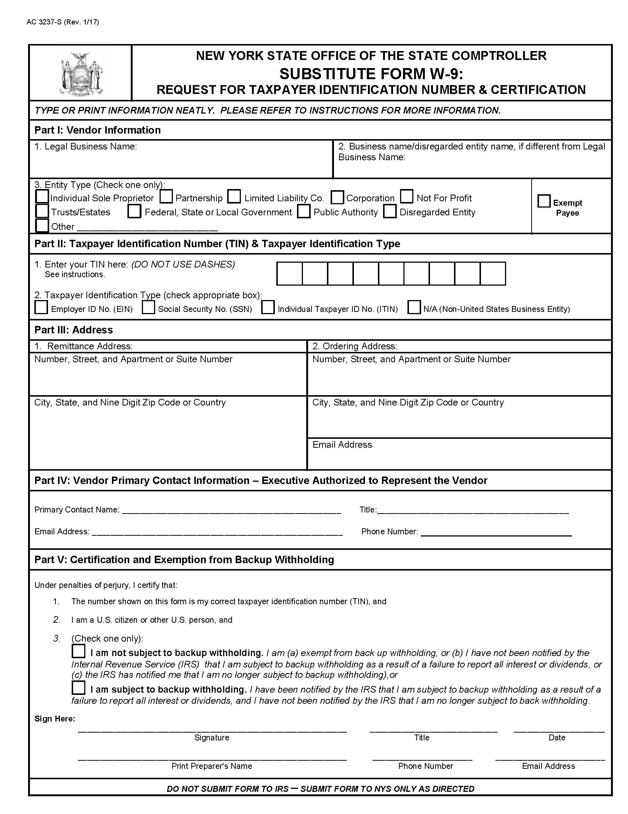

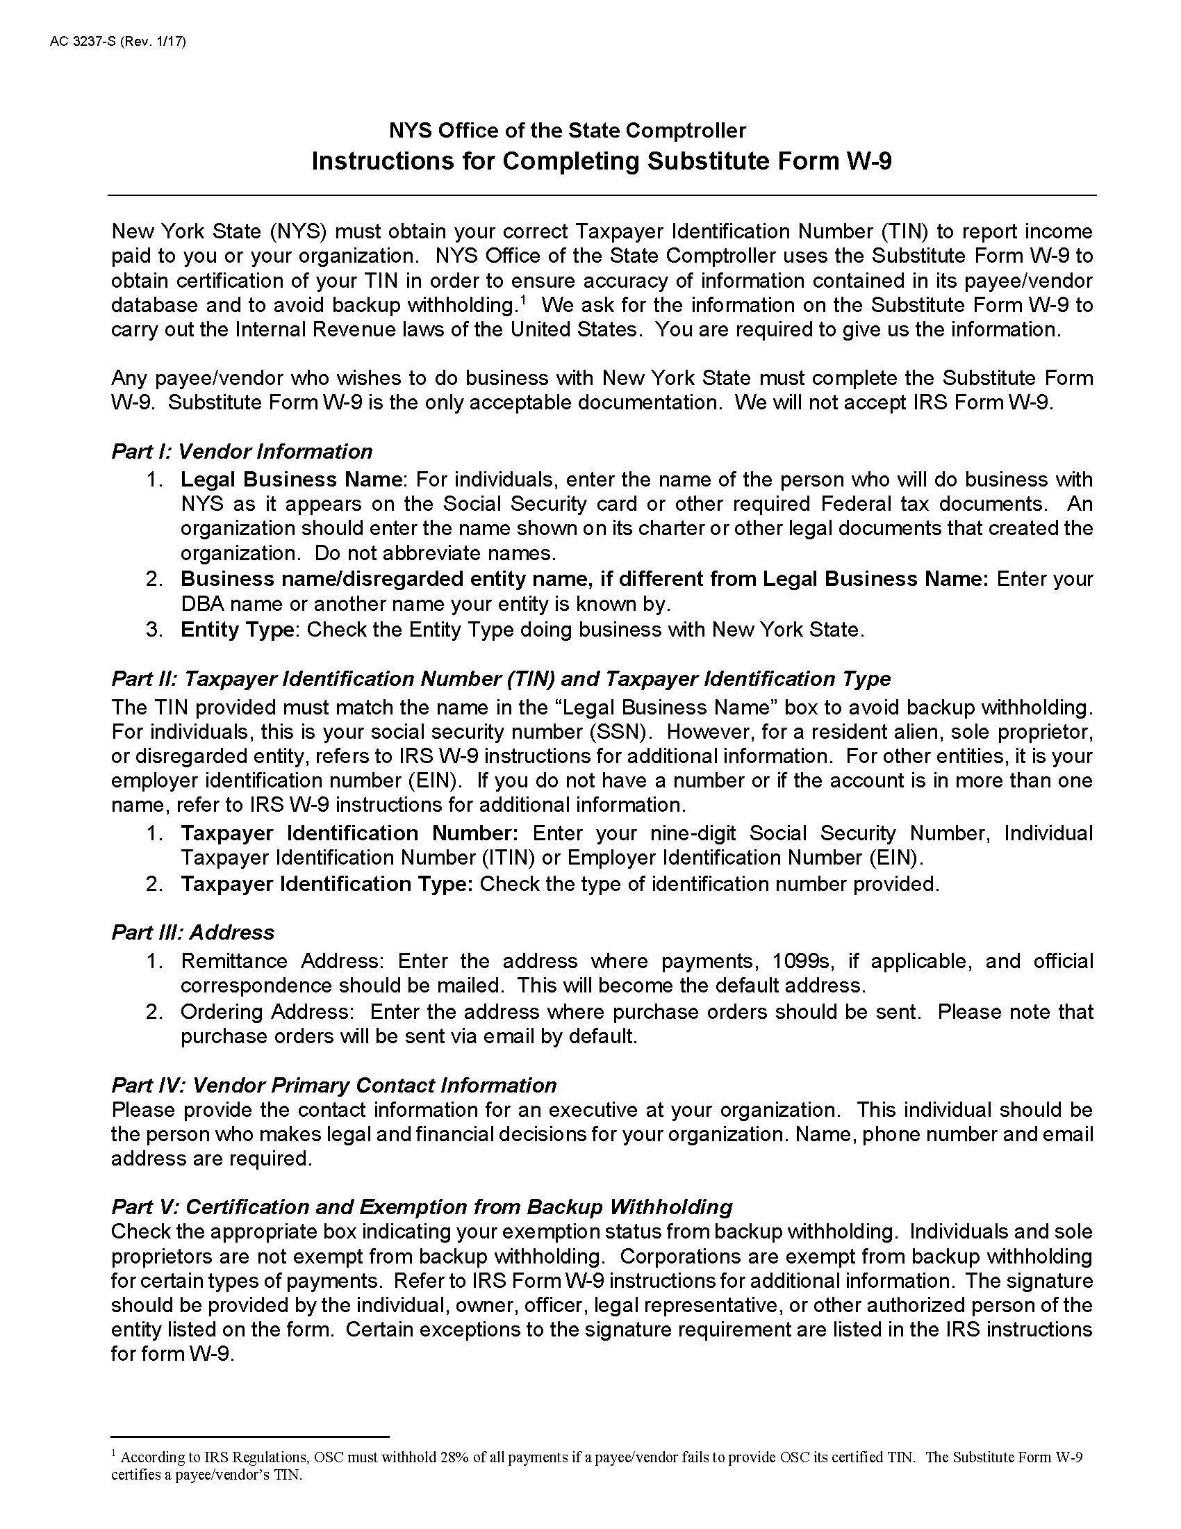

EXHIBIT D

Minority and Women-Owned Business Enterprises – Equal Employment Opportunity Policy Statement
M/WBE AND EEO POLICY STATEMENT
I, _________________________, the (awardee/contractor)____________________ agree to adopt the following policies with respect to the project being developed or services rendered at __________________________________________________________________________________
M/WBE

EEO

This organization will and will cause its contractors and subcontractors to take good faith actions to achieve the M/WBE contract participations goals set by the State for that area in which the State-funded project is located, by taking the following steps:
- Actively and affirmatively solicit bids for contracts and subcontracts from qualified State certified MBEs or WBEs, including solicitations to M/WBE contractor associations.
- Request a list of State-certified M/WBEs from AGENCY and solicit bids from them directly.
- Ensure that plans, specifications, request for proposals and other documents used to secure bids will be made available in sufficient time for review by prospective M/WBEs.
- Where feasible, divide the work into smaller portions to enhanced participations by M/WBEs and encourage the formation of joint venture and other partnerships among M/WBE contractors to enhance their participation.
- Document and maintain records of bid solicitation, including those to M/WBEs and the results thereof. Contractor will also maintain records of actions that its subcontractors have taken toward meeting M/WBE contract participation goals.
- Ensure that progress payments to M/WBEs are made on a timely basis so that undue financial hardship is avoided, and that bonding and other credit requirements are waived or appropriate alternatives developed to encourage M/WBE participation.

  - This organization will not discriminate against any employee or applicant for employment because of race, creed, color, national origin, sex, age, disability or marital status, will undertake or continue existing programs of affirmative action to ensure that minority group members are afforded equal employment opportunities without discrimination, and shall make and document its conscientious and active efforts to employ and utilize minority group members and women in its work force on state contracts.
  - This organization shall state in all solicitation or advertisements for employees that in the performance of the State contract all qualified applicants will be afforded equal employment opportunities without discrimination because of race, creed, color, national origin, sex disability or marital status.
  - At the request of the contracting agency, this organization shall request each employment agency, labor union, or authorized representative will not discriminate on the basis of race, creed, color, national origin, sex, age, disability or marital status and that such union or representative will affirmatively cooperate in the implementation of this organizations’ obligations herein.
  - Contractor shall comply with the provisions of the Human Rights Law, all other State and Federal statutory and constitutional non-discrimination provisions. Contractor and subcontractors shall not discriminate against any employee or applicant for employment because of race, creed (religion), color, sex, national origin, sexual orientation, marital status or domestic violence victim status, and shall also follow the requirements of the Human Rights Law with regard to non-discrimination on the basis of prior criminal conviction and prior arrest.

- This organization will include the provisions of sections (a) through (d) of this agreement in every subcontract in such a manner that the requirements of the subdivisions will be binding upon each subcontractor as to work in connection with the State contract.

Agreed to this _______ day of ____________________, 2___________
By __________________________________________
Print: _____________________________________ Title: _____________________________
Minority Business Enterprise Liaison
_________________________________is designated as the Minority Business Enterprise Liaison
(Name of Designated Liaison)
responsible for administering the Minority and Women-Owned Business Enterprises- Equal Employment
Opportunity (M/WBE-EEO) program.
M/WBE Contract Goals
________% Minority Business Enterprise Participation
________% Women’s Business Enterprise Participation

EEO Contract Goals
________% Minority Labor Force Participation
________%Female Labor Force Participation

____________________________________________
(Authorized Representative)
Title: ________________________________________
Date: ________________________________________

EXHIBIT E

Contractor Sales Tax Certification Forms
These forms are available at the New York State Department of Taxation and Finance website:
ST-220-TD: https://www.tax.ny.gov/pdf/current_forms/st/st220td_fill_in.pdf
ST-220-CA: https://www.tax.ny.gov/pdf/current_forms/st/st220ca_fill_in.pdf
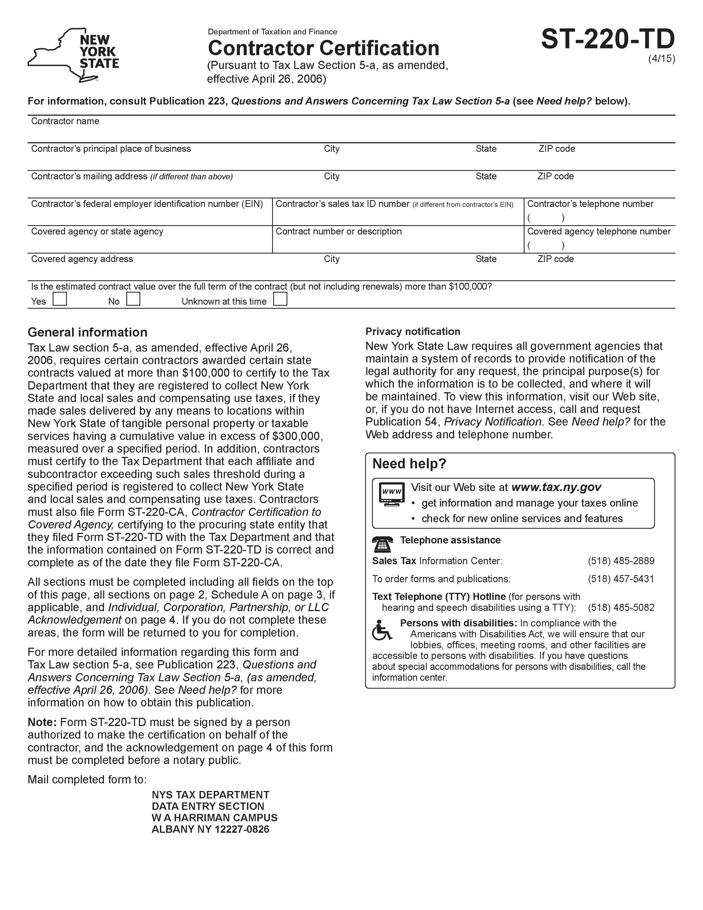

EXHIBIT F

Workforce Utilization Report

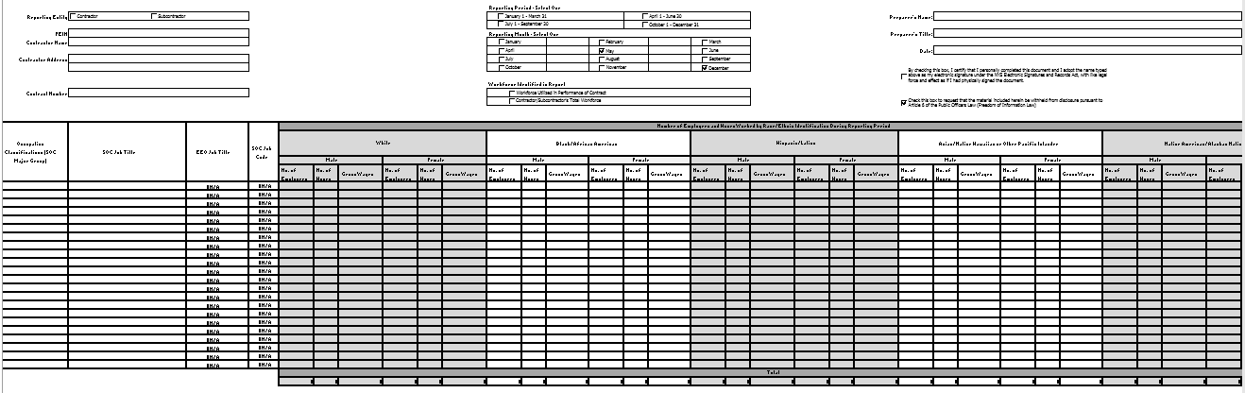
Note: An Excel file of this form will be provided to the Contractor after contract execution.

The draft IPS has not yet been approved by the Board.

